IOT Based Food Monitoring System

Background
The IoT has enabled smart monitoring in various fields, including food storage. Fruits and vegetables release gases like methane during ripening, and their freshness depends on temperature and humidity. Traditional methods cannot detect spoilage early, leading to wastage. IoT-based systems can continuously monitor these conditions, alert users, and maintain proper storage.

Manual monitoring of food storage is slow and prone to error. Spoiled food may go unnoticed, leading to wastage and health risks. There is a need for a real-time system that measures temperature, humidity, and gas levels, provides alerts, and controls cooling to prevent spoilage.

  - introduction
Maintaining safe storage conditions is crucial for reducing food spoilage. IoT-based sensors can monitor environmental parameters continuously, alert users when thresholds are crossed, and automate responses such as activating fans or buzzers, ensuring better food preservation.

  - importance of study
This study helps prevent food spoilage by providing real-time monitoring and alerts. Automated control reduces manual effort, improves efficiency, ensures timely intervention, and minimizes wastage, contributing to safer storage and better resource utilization.

  - organization of report
The report is structured to provide a clear understanding of the project. Chapter 1 covers introduction, background, and problem statement. Chapter 2 reviews literature and identifies gaps. Chapter 3 discusses hardware, software, block diagram, flow diagram, and methodology. Chapter 4 details implementation and results, and Chapter 5 concludes with findings and future scope.

Chapter 2
Literature Review
2.1. motivation for literature review
(description of the Types of techniques/domains related to project 5-6 lines)
S.N | PAPER TITTLE &  PUBLICATION DETAILS | NAME OF THE AUTHORS | TECHNICAL IDEAS / ALGORITHMS USED IN THE PAPER & ADVANTAGES | SHORTFALLS/DISADVANTAGES &  SOLUTION PROVIDED BY THE PROPOSED SYSTEM
1
  IoT-Based Smart Food Monitoring System, IEEE Conference, 2022
  R. Kumar et al.
  Uses MQ-series sensors and NodeMCU for gas detection;
  Lacks automatic cooling mechanism and alert prioritization. Proposed system adds a 12V fan control and buzzer alert with threshold logic.
2
  Temperature and Humidity Tracking for Food Storage, Journal, 2021
  A. Sharma & P. Singh
  Uses DHT11 with cloud integration;
  No methane detection for ripening fruits. Proposed system integrates MQ-4 for early spoilage detection.
3
  Gas Leakage and Spoilage Monitoring using IoT, Elsevier, 2020
  L. Fernandez et al.
  MQ sensors with machine-to-cloud communication; remote alerts via mobile app.
  No fan or ventilation control; only sends alerts. Proposed system automates cooling using a 12V DC fan.
4
  Smart Storage Management with IoT and Blynk App, IEEE Access, 2021
  S. Banerjee & T. Roy
  Uses Blynk for remote monitoring; supports manual control of devices.
  Manual operation only; no automatic decision-making. Proposed system includes automatic fan ON/OFF based on threshold values.
5 |  |  |  | No buzzer mechanism; lacks combined temperature–gas correlation. Proposed system integrates buzzer alert and multi-sensor decision-making.
  Real-Time Food Quality Monitoring using Gas Sensors, International Journal of IoT, 2023
  M. Ali & K. Patel
  Focuses on gas-level analysis using MQ-2/MQ-4 sensors; provides reliable spoilage prediction.

2.2. GAPS IDENTIFIED
Existing systems mainly monitor temperature and humidity but often ignore methane gas detection. Many lack automated cooling and buzzer alerts. Manual monitoring and limited mobile control reduce efficiency. The proposed system addresses these gaps by integrating multi-sensor monitoring, automatic fan control, buzzer alerts, and Blynk-based notifications.

2.3. OBJECTIVES
The project aims to monitor temperature, humidity, and methane gas in real time. It provides alerts through a buzzer and mobile app and controls a cooling fan automatically. Users can also manually operate the fan through Blynk, ensuring food safety and reducing wastage.

The system is designed to provide an intelligent solution for food storage monitoring by integrating multiple sensors and automated controls. By continuously collecting and analyzing environmental data, it aims to prevent spoilage before it occurs. The objectives also include ensuring user convenience through real-time notifications and remote control via the Blynk application. Ultimately, the project seeks to create a cost-effective, reliable, and easy-to-use system that enhances food safety and reduces wastage in both domestic and commercial storage environments.

Chapter 3
Materials Methodology
3.1. functional requirements/dataset/inputs taken
The system must continuously measure temperature and humidity using the DHT11 sensor, as these parameters directly affect the freshness of stored fruits and vegetables.
- Methane gas detection is performed by the MQ-4 sensor to identify ripening or potential spoilage, providing an early warning mechanism.
- The ESP32 NodeMCU processes sensor data, compares readings against predefined thresholds, and triggers necessary actions. Outputs include activating a 12V cooling fan to maintain safe storage conditions and a passive buzzer for audible alerts.
- Additionally, the system communicates with the Blynk IoT application, allowing users to monitor real-time data and manually control the fan if needed. Each of these inputs and functional requirements ensures the system operates reliably, prevents food spoilage, and provides a user-friendly interface for monitoring and control.

3.2. software requirements
- Arduino IDE – Provides an environment to write, compile, and upload code to the ESP32 NodeMCU, enabling the system to read sensors and control devices.
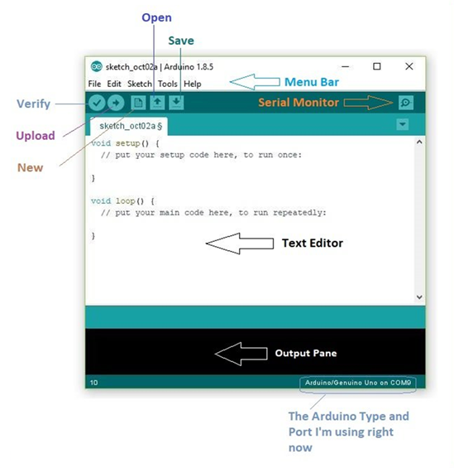
Fig 3.2- Arduino IDE
- ESP32 Board Package – Supplies the necessary libraries and definitions to program the ESP32 microcontroller correctly.
- DHT11 Sensor Library – Facilitates easy reading of temperature and humidity values from the DHT11 sensor.
- MQ-4 Sensor Library – Allows the ESP32 to accurately read methane gas levels and detect spoilage indicators.
- Blynk IoT Application – Displays real-time sensor data on a mobile device and allows manual control of the fan, providing user-friendly monitoring and alert notifications.
- Wi-Fi Network – Enables cloud connectivity between ESP32 and Blynk, ensuring real-time updates and remote access.

3.3. hardware requirements
- ESP32 NodeMCU – Acts as the main microcontroller, processes data from sensors, controls the fan and buzzer, and communicates with the Blynk IoT app.

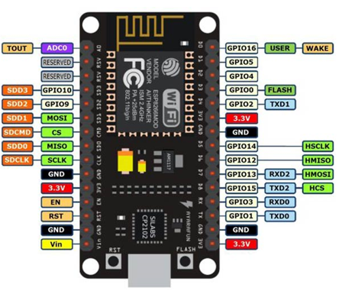

Fig 3.3.1- Node MCU ESP8266
- MQ-4 Methane Gas Sensor – Detects methane gas released from ripening or spoiled food, providing an early warning of potential spoilage.
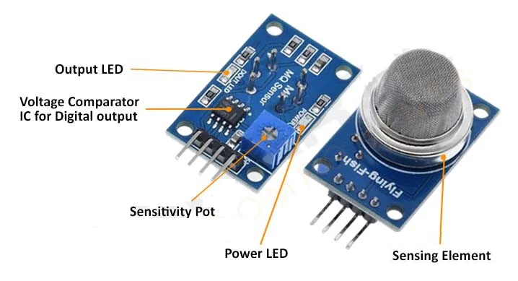
Fig 3.3.2- MQ-4 Methane Gas Sensor
- DHT11 Temperature & Humidity Sensor – Measures real-time temperature and humidity in the storage area to maintain optimal storage conditions.
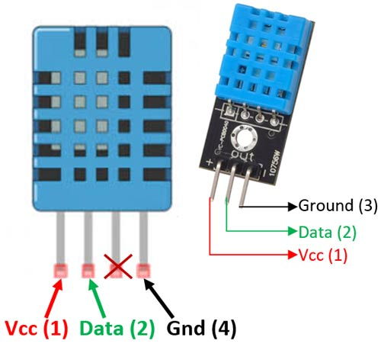
Fig 3.3.3- DHT11 Temperature & Humidity Sensor

- 12V DC Cooling Fan (with Relay Module) – Automatically or manually activated to reduce temperature and control the storage environment, preventing spoilage.
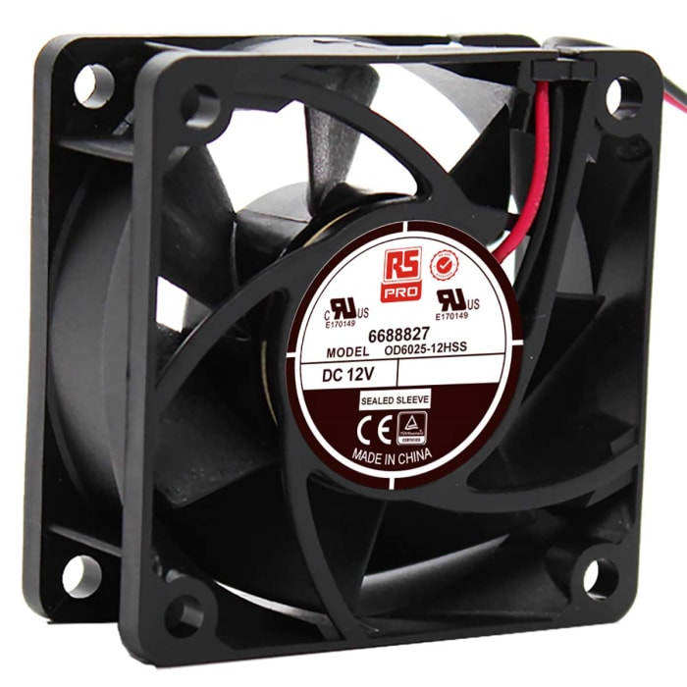
Fig 3.3.4-12V DC Cooling Fan
- Passive Buzzer – Provides audible alerts whenever temperature, humidity, or methane gas thresholds are exceeded.
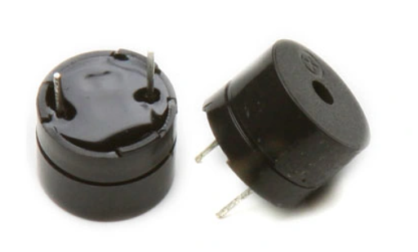
Fig 3.3.5- Passive Buzzer
- Power Supply (12V with 5V Converter) – Provides stable power to the ESP32 and sensors, ensuring uninterrupted operation of the system.

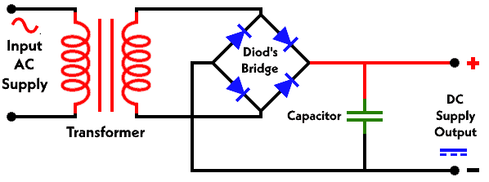
Fig 3.3.6- Power Supply

3.4. technologies used:
- Internet of Things (IoT) – Enables real-time monitoring of environmental conditions and remote control of devices through the internet.
- Sensor Technology (DHT11 & MQ-4) – Detects temperature, humidity, and methane gas to monitor the freshness of stored fruits and vegetables accurately.
- Blynk IoT Platform – Cloud-based application for real-time visualization, alert notifications, and manual device control via a mobile interface.

3.5. Block Diagram
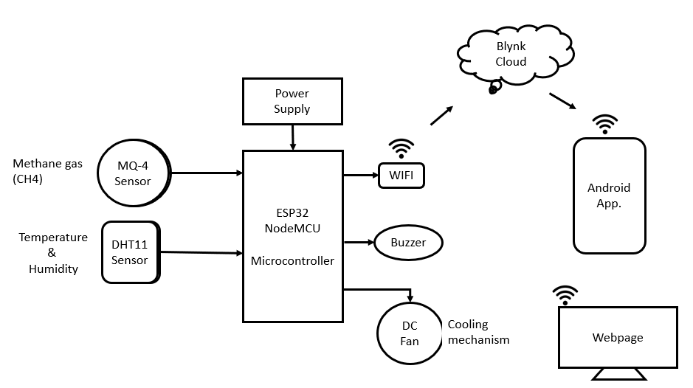
Fig 3.5-Block Diagram

The block diagram illustrates the structure and interaction of components in the IoT-based Food Monitoring System. The ESP32 NodeMCU serves as the central controller, receiving inputs from the DHT11 sensor for temperature and humidity, and the MQ-4 sensor for methane gas detection. Based on these readings, it activates the 12V cooling fan via a relay and triggers the passive buzzer for alerts. Simultaneously, the ESP32 communicates with the Blynk IoT application over Wi-Fi, allowing users to monitor real-time data and manually control the fan when necessary. The diagram provides a clear overview of data flow and system functionality.

Chapter 4
Results and Discussion
4.1. Results
This figure shows real-time monitoring of temperature, humidity, and methane gas levels on the Blynk application dashboard. The system updates values continuously, allowing the user to track storage conditions remotely.

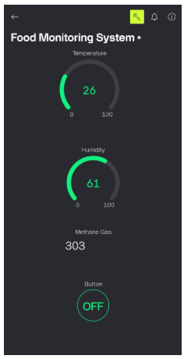

Figure 4.1: Sensor Data Display on Blynk App

The buzzer is activated automatically when any parameter exceeds the predefined threshold, providing an audible warning to alert the user of potential spoilage.


Fig 4.2: Buzzer Alert Activation
The cooling fan switches on automatically when high temperature or methane gas levels are detected, helping to maintain optimal storage conditions and prevent food spoilage.


Fig 4.3: Automatic Fan Operation
Users can override the automatic control and operate the fan manually from the Blynk application, providing full control over the storage environment as needed.


Fig 4.4: Manual Fan Control via Blynk App

Chapter 5
Conclusion

The IoT-based Food Monitoring System successfully monitors temperature, humidity, and methane gas levels to ensure the freshness of stored fruits and vegetables. Using the ESP32 NodeMCU, the system provides real-time alerts via a passive buzzer and the Blynk IoT application, while also controlling a 12V cooling fan automatically or manually to maintain optimal storage conditions. This project reduces food spoilage, minimizes manual monitoring efforts, and offers a user-friendly interface for remote control and notifications. In the future, the system can be enhanced by integrating multiple storage units, using more advanced sensors for detecting other gases, adding AI-based prediction for spoilage, and enabling cloud-based data analytics for long-term monitoring. Overall, the project demonstrates an effective and practical solution for smart food preservation.

References
Books
- S. Sharma, Internet of Things: Architecture and Applications, Wiley, 2020.
- Raj Kumar Buyya, Internet of Things: Principles and Paradigms, Morgan Kaufmann, 2019.
- James Kurose & Keith Ross, Computer Networking: A Top-Down Approach, Pearson, 2021.
- Arshdeep Bahga & Vijay Madisetti, Internet of Things: A Hands-On Approach, Universities Press, 2017.
- John Wiley, Embedded Systems Design Using Microcontrollers, 2018.

Research Papers
- A. Kumar, “IoT-Based Smart Food Monitoring System,” International Journal of Engineering Research, 2021.
- R. Singh & S. Gupta, “Real-Time Food Spoilage Detection Using Gas Sensors,” IEEE Sensors Journal, 2020.
- P. Verma et al., “IoT Architecture for Smart Agriculture Monitoring,” International Journal of Advanced Research in Electronics, 2019.
- L. Thomas, “Gas Sensor-Based Monitoring for Food Storage,” International Conference on IoT Systems, 2022.
- M. Patel, “Temperature and Humidity Monitoring in IoT Applications,” IJRET, 2021.

Websites
- Arduino Official Documentation – https://www.arduino.cc
- ESP32 Documentation (Espressif) – https://docs.espressif.com
- Blynk IoT Platform – https://blynk.io
- MQ-4 Sensor Technical Details – https://components101.com
- DHT11 Sensor Guide – https://randomnerdtutorials.com

